Modual – 1

1. **What is software? What is software engineering**

**What is software**

* Computer instructions or data, anything that can be stored electronically is software.
* Software is work from users to interact with computer. it is not touchable.
* It is a read and watch on screen.
* Software refers to the set of instruction using the programming languaje control to hardware.
* Software is intangible.
* example of software bis given below.
* WindowsOS, Linux, Word, Excle etc...

**Software engineering.**

* Software Engineer is a bench of Computer Science.
* Software engineering is work from software industry.
* Software is an intangible.
* Its applies to the principle of software engineering to the design, development,testing of computer software.
* Software engineering is a build to software.
* It is work for education in software
* In software engineering is teamwork is a most important.

**2. Explain type of software ?**

There are 5 types of software

- Application software

- System software

- Driver software

- Middleware software

- Programming software

* **Application software**

- This software that a perform specifyc task to user needs is called a Application software.

- Application software are installed according to user’s requirements.

- It is a type of software application that helps in the automation of the task based on the Users Input.

- it is a perform single or multiple task at the same time

- different application's help to our daily life to process on instructions based rules and regulation.

- High level language is used to application software.

EX., word, Excel, PowerPoint etc.

* **System software**

- System software is use from operating computer hardware.

- It is work for electronic devise. In this software OS is the best example.

- System software is work for independently.

- These software programs are designed to run a computer's application

programs and hardware.

- System software coordinates activities and functions of the hardware

and software.

- It is manages at all the other computer program.

Ex :- Notepad ,Calculator etc.

* **Driver software**

- Driver is a included in an operating system.

- Driver is a instrutation in computer's all part.

- Driver is a work for solve all issues and aware to any problems.

- There are a various type of driver

- Keyboard, printers, controllers.

* **Middleware software**

- Middleware software is a developers and operators build to efficientily.

- Middleware software and cloud services that provide common services and capabilities to build the application.

-

* **Programming software**

- Computers programmers use programming software to write code.

-Programming software is in a include a programming tools enable to develop code.

- Programming software is a instruction of all code to prepare a program.

- Programming software is a use to create a applications, websites, games and many other part

- This software is totally work from programming bais.

- In programming software are use to many different languages are use to creating a program.

EX., PHP, HTML, CSS etc.

**3. What is SDLC? Explain each phase of SDLC**

SDLC :- Software Development Life Cycle

- Software Development Life Cycle is refers to a methodology with clearly defined processes for creating high-quality software.

* There are VI type of SDLC

I. Planning

II. Analysis

III. Design

IV. Implementation

V. Testing & integration

VI. Maintenance

**Planning :-**

- SDLC in first create to planning and after for work in SDLC.

- There are most important part of anything work.

- without planning is not success any work.

- In this involve defining the scope of the software.

- Planning for the requirement and identifactions of the risk with the project is also done at this stage.

**Analysis :-**

- Requirement anakysis is the most imporatant and necessary satge in SDLC.

- After planning clients are analysis to your work.

- Produce owner is analysis in SDLC.

- project manager are also Analysis to SDLC.

- Client is show all items and response to all.

**Design :-**

- Design is the basic structure of the software.

- System software is in include programming language, templates, plateform to use.

- Any work for important to best design.

- Define solution system based on requirement and analysis decision.

- It is necessary to create a good design to attract people.

**Implementation :-**

* Any work need by implementation for construct.
* There are more increase to user install the app.
* If Client have more train users, so more implementation.
* Program coding is best so implementation is best.

**Testing & integration :-**

* Project testing is important to solve the bugs.
* Testing is a solution of architect.
* To be testing by a tester.
* Some time coding mistake is solve to testing.

**Maintenance :-**

* Users are charged according to maintenance.
* Tester work done by taken Maintenance.
* Supporter managers are management chare are including the Maintenance
* All work complete then after take a Maintenance

**4. What is DFD? Create a DFD diagram on Flipkart**

- A data-flow diagram is a way of representing a flow of data.

- The DFD is also provide information about the output and input for each intity.

- A data -flow diagram has no control to flow.

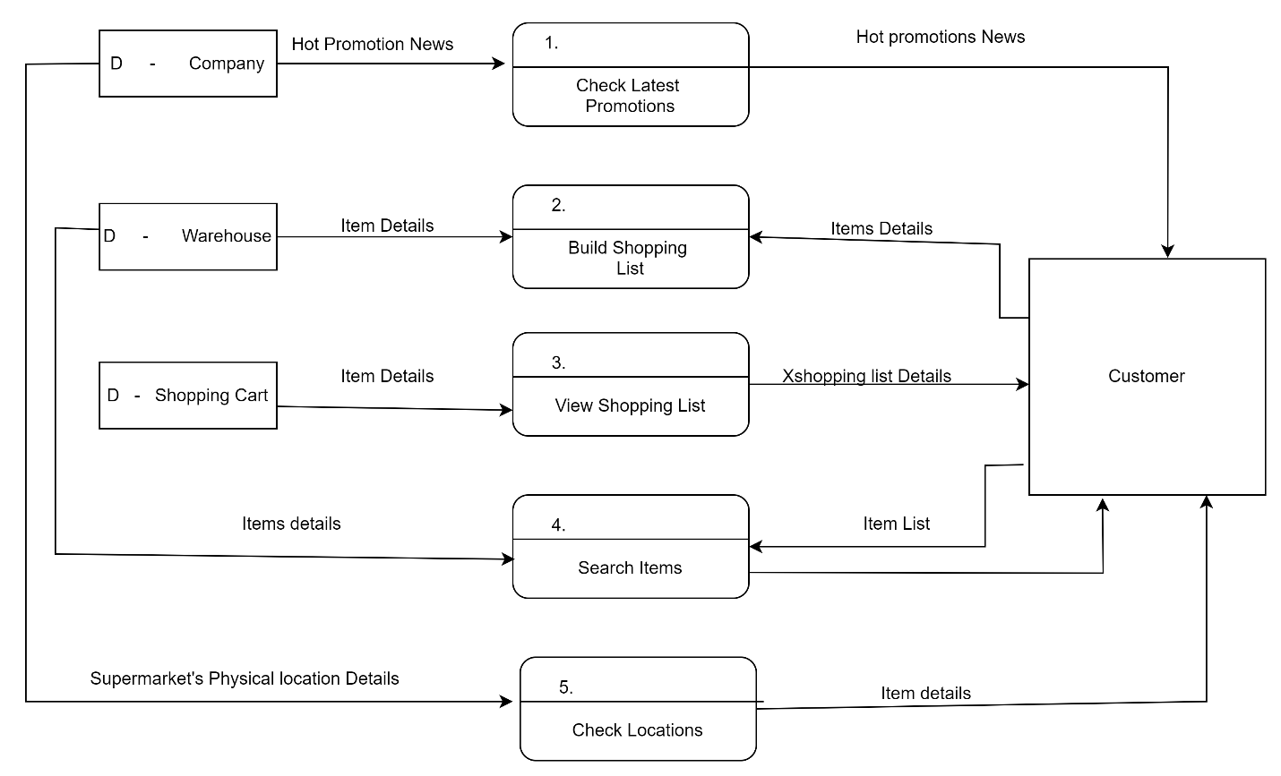

**5. What is Flow chart? Create a flowchart to make addition of two numbers**

**Flow chart :-**

- A flowchart is a diagram that show an overview of a program.

- Flow chart is a normally used by symbols to represent the different instructions.

- Flow chart's symbols is show the flowchart.

- It is a represent by the step by step solution to the program.

**Flowchart :-**

**Declare variable1num1, num2 and sum**

**Read num1 and num2**

**Print Sum**

**Add num1, num2 and assign value to Sum**

**Sum=num1 + num2**

**6.** **What is Use case Diagram? Create a use-case on bill payment on paytm.**

**-** Case diagram is graphical of a user’s possible interactions with a system.

- A user can Diagram shows various use cases and different types of users the system has and will often by other type of diagram as well.

- Case diagram is describe the high-level functions and score of a system.

- use case is a written description of how users will perform task on your websit.

